Temsah Verilog
Full-Custom Design | Semi-Custom Design (Standard Cells)
Transistor Level | Gate Level
Huge Design Effort | Reasonable Design Effort
High Performance | Less Performance

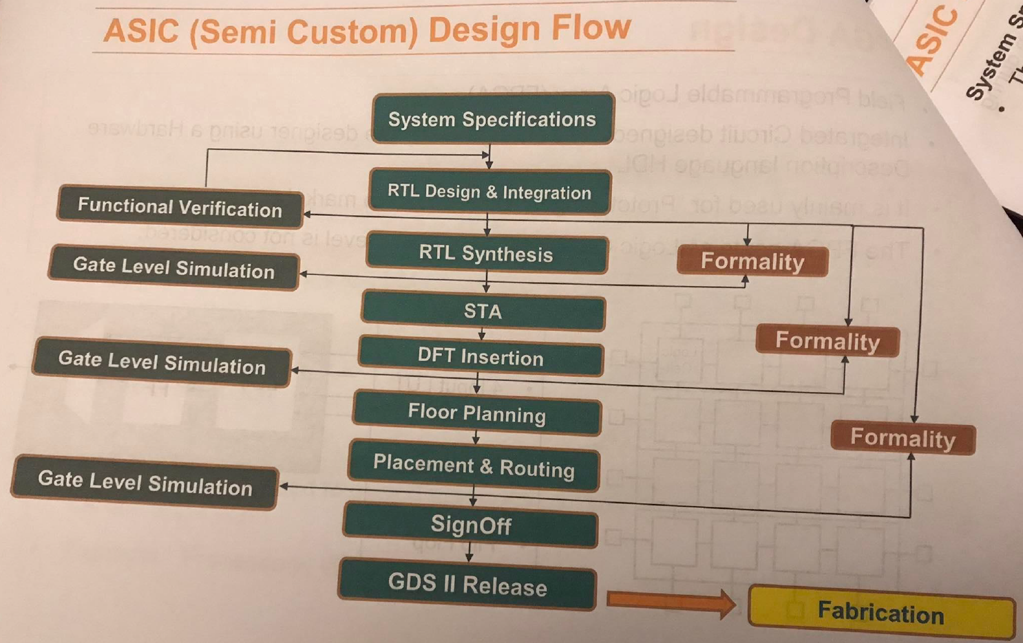
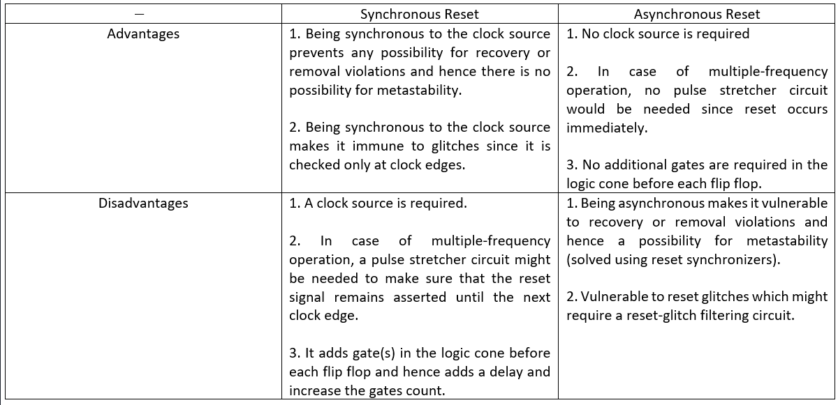
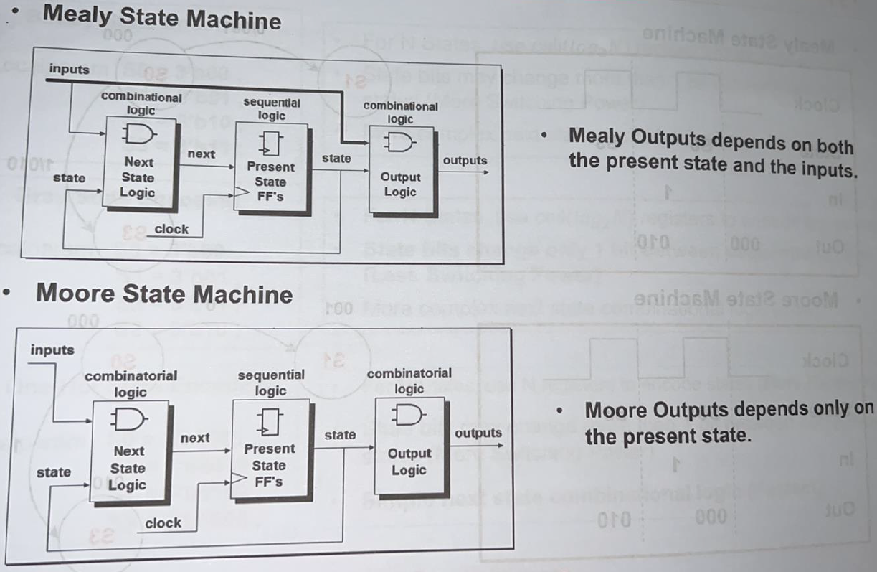
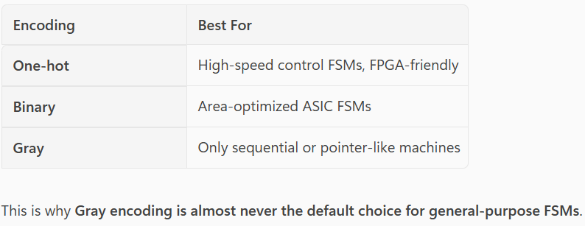

Dr. Kareem Course 1
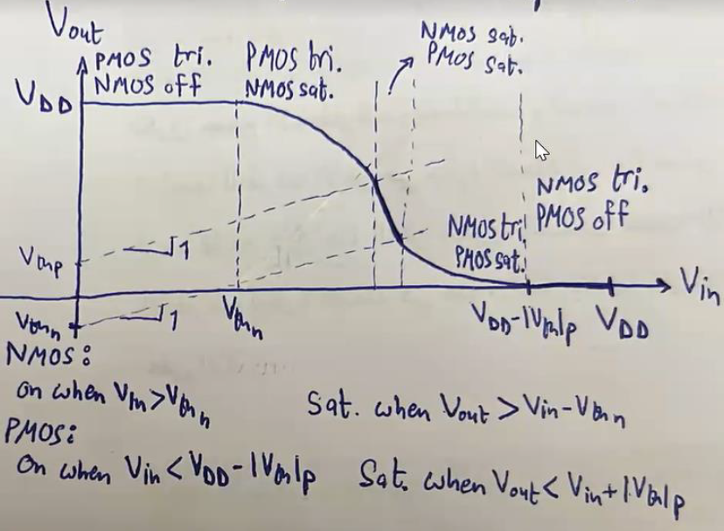
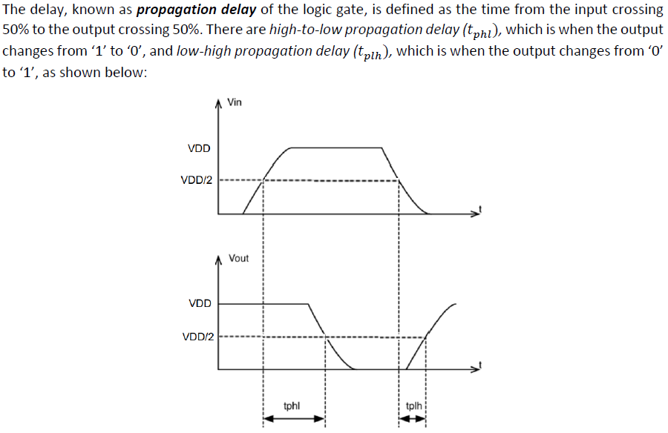
- $L=L_{min}$.
- $W:$ the larger the width of a transistor, the larger its capacitance $C$, and the smaller its resistance $R$.
- $τ=RC=R\left(C_{int}+C_{ext}\right)=RC_{int}+RC_{ext}$. Thus, increasing the width of a gate doesn’t change its intrinsic delay, but it decreases the extrinsic delay. Accordingly, the gate’s overall delay decreases. However, this increases the delay of the gate before.
- For a PMOS to have the same resistance as an NMOS, it should have double the size.
- Switching power:
$$P_{sw}=αfC_{L}V_{DD}^{2}$$
- A static positive-edge flip flop consists of a negative latch followed by a positive latch, which reduces to a few transmission gates and inverters.
- How do delay and power depend on supply voltage?
  - $τ∝RC, R∝\frac{V_{DD}}{I}, I∝{\left(V_{DD}-V_{th}\right)}^{2}, ∴R∝\frac{V_{DD}}{{\left(V_{DD}-V_{th}\right)}^{2}}, ∴τ∝\frac{V_{DD}}{{\left(V_{DD}-V_{th}\right)}^{2}}≈\frac{1}{V_{DD}}$
  - $P_{sw}=αC_{L}fV_{DD}^{2}$, $P_{sw}∝V_{DD}^{2}$
- Easiest way to make sure all data is aligned after pipelining howa enak to2af 3and output mo3ayan fel circuit w temshy le wara le kol el inputs leeh w tet2aked en kolohom shayfeen nafs el latency.
- pipelining is used to improve throughput through trying as much as possible not to allow Processing Units (PUs) to be idle by adding pipelining registers between PUs. This results in an increase in the operating clock frequency, an increase in latency when counted in number of cycles, and latency in absolute time units might not change because the clock period drops relative to the unpipelined case. Never say pipelining is used to increase clock frequency, it is used to increase throughput in the first place and clock frequency increases by the way.

Dr. Kareem Course 2
- The wire model is as shown below:
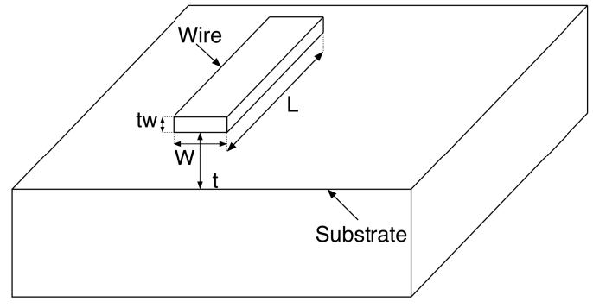
- $τ_{wire}∝RC=\frac{ρL}{A}×\frac{ϵA}{d}=\frac{ρL}{Wt_{w}}×\frac{ϵWL}{t}=\frac{ρϵL^{2}}{t_{w}t}∴τ_{wire}∝\frac{L^{2}}{t_{w}t}$
- As technology advances, transistors become smaller, hence they become closer to each other, which means local wires become shorter. But does this mean their delay become smaller? No, because all other dimensions scale down as well, hence $τ_{wire}∝\frac{{\left(\frac{L}{k}\right)}^{2}}{\frac{t_{w}}{k}.\frac{t}{k}}=\frac{L^{2}}{t_{w}t}$, which means the delay of local wires remains constant as technology advances.
- As technology advances, chips become larger, which means global wires become longer, hence $τ_{wire}∝\frac{{\left(k_{w}L\right)}^{2}}{\frac{t_{w}}{k}.\frac{t}{k}}=k^{2}k_{w}^{2}.\frac{L^{2}}{t_{w}t}$, which means the delay of global wires increases dramatically as technology advances.
- Accordingly, wires delay became the significant source in advanced chips:
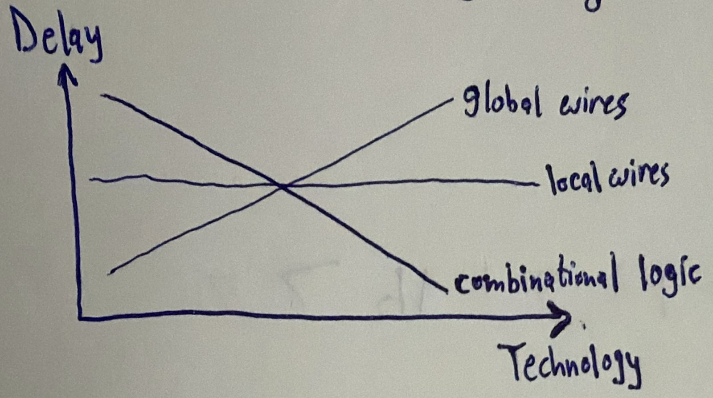
- One way to mitigate the global wires delay is to increase the wires thickness $t_{w}$. However, increasing the wires thickness $t_{w}$ leads to the increase of a type of capacitance called interwire capacitance that causes crosstalk between adjacent wires. To decrease interwire capacitance, adjacent wires have to be farther separated. This leads to hierarchical routing:
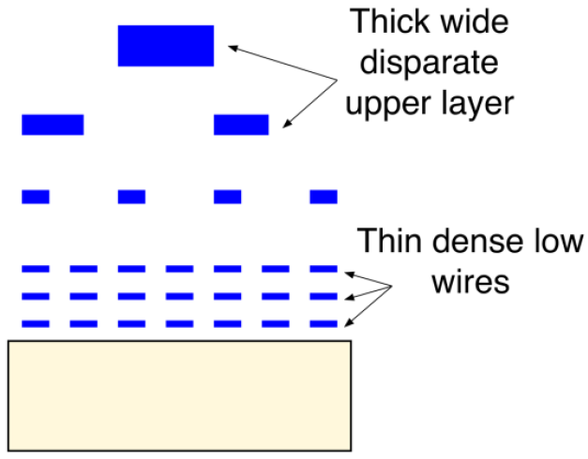
- Wires in higher metal layers are made thicker to decrease the delay, but to avoid the increase of interwire capacitance, they are farther separated. Hence, wires in higher metal layers are used for global routing, while wires in lower metal layers are used for local routing.
- What determines whether clock skew is positive or negative?
  - If the clock and data are moving in the same direction positive skew.
  - If the clock and data are moving in opposite directions negative skew.
- Who decides the direction of clocks?
  - The “clock distribution network” made by the routing tool.
- Lw el tool 3andaha el 7oreya enaha te5tar positive skew aw negative skew, hate5tar eh?
  - Ana ma3andeesh el egaba bs 3andy two guesses. Awel guess howa enaha hate5ar el 7aga el te2alel el violations el 7asla. Y3ny lw fih setup violation, fa heya hate5tar positive skew 3ashan tesa3do, lw fi hold violation, fa heya hate5tar negative skew 3ashan tesa3do. El guess el tany howa: lw el chip etsana3et w fiha setup violation fa momken ne7elo be enena ne2alel el frequency bta3t el chip w hateshtaghal, not ideal bs hateshtaghal. Laken lw el chip etsana3et w fiha hold violation fa de karsa. Fa momken el tool dayman te5tar enaha tesa3ed el hold, y3ny negative skew.
- Clock jitter occurs due to phase noise in oscillators.
- Clock jitter has no effect on hold time.
- Two clocks are said to be in the same clock domain if and only if they have a constant phase relationship. For this to happen:
  - The two clocks must be generated from the same source: otherwise, the two sources would have different initial settling times and hence no constant phase relationship.
  - The two clocks must be integer multiples from each other: otherwise, they wouldn’t have a constant phase relationship.
- What could happen in a flip flop when it goes metastable?
  - Scenario 1: lw enta ghayart el input orayeb awy men el clock edge, fa el flip flop mesh hayshoof el taghyeer da w hayezhar fel clock cycle el bad3eha.
  - Scenario 2: lw enta ghayart el input fel nos mabeen el setup time wel clock edge, fa el output hy glitch, y3ny hayro7 lel output bta3 el input el geded w yerga3 tany, wel output el sa7 da hayezhar el clock cycle el ba3deha.
  - Scenario 3: lw enta ghayart el input b3d el setup time 3la tool, fa el output el sa7 hayezhar fi nafs el clock cycle bs b3d wa2t atwal men el expected el howa $t_{cq}$.
These 3 scenarios apply to hold time as well, kol el far2 eno b3d el edge badal ablo.

- Other than high $t_{cq}$, metastability can cause propagation of different values at the same time:
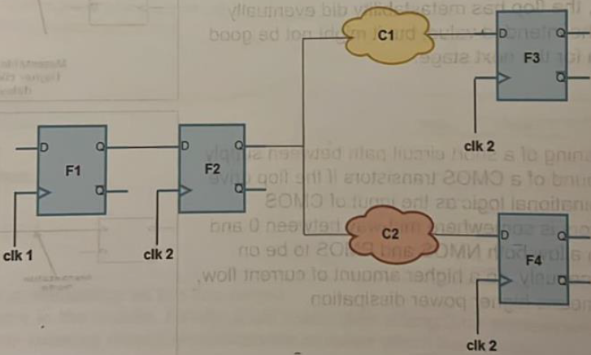
- We already know that the solution for a single-bit CDC is to place a double-flop synchronizer. But why two flip flops exactly, why not a single flip flop?
  - El flip flop el beya5od el sadma (i.e. awel wa7ed fel clock domain el geded) da el MTBF bta3o beyeb2a bel microseconds aw seconds. That is, el flip flop da beyet-hery metastability, kol a few microseconds or seconds beyeb2a metastable, y3ny el output bta3o beye7sal fih wa7ed men el 3 scenarios el olna 3leehom foo2, bs 5alena nrakez 3la el scenario bta3 eno el $t_{cq}$ beteb2a akbar. Fa lw e7na da55alna el frequently-metastable output da 3al circuit el ba3deha el heya fiha combinational clouds, fa bsabab el $t_{cq}$ el akbar da either hayefdal ye7sal setup violation aw propagation of different values kol shwaya zy ma olna. However, lw ana 7ateet flip flop tany wara el flip flop el 3amal yed5ol fi metastability da w damant en mafeesh ay logic mabenhom, fa ana keda damen en lama el output bta3 el flip flop el awalany da yewsal lel flip flop el tany, fa el flip flop el tany da mesh hayed5ol fi metastability la2en el path literally mafehosh gheer el $t_{cq}$ bta3 awel flip flop, fa 7ata lw b2a atwal shwaya bsbb el metastability fa da bardo hayeb2a still a2sar men en howa yed5ol fi metastability, wel analysis bet2olena en el probability eno yed5ol fi metastability almost zero. Fa keda el flip flop el tany da hayeb2a dayman el output bta3o super clean as shown below:
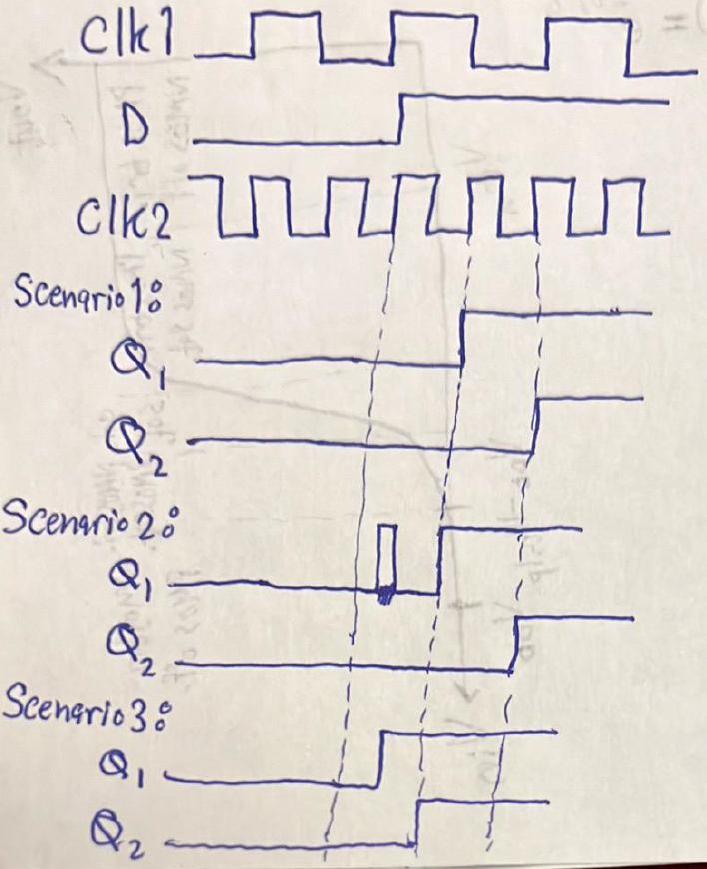
W 3ashan keda it’s super important not to place any logic between the two synchronizer’s flops; 3ashan adman en el output bta3 awel flop yo5rog men el metastability w yewsal lel flip flop el tany abl el setup/hold window bta3to w bel taly maye3melsh fih metastability.
- Notice that the output of a double-flop synchronizer has a one-cycle uncertainty: momken tetla3 b3d 2 or 3 clock cycles, bs at least damen enaha hatetla3 be shakl synchronous mesh metastable.
- Why can’t we synchronize a bus using multiple single-bit synchronizers? Because all synchronizers are not guaranteed to behave the same for the below two reasons and hence could cause garbage data to appear at the receiver:
  - Some synchronizers might become metastable while the others are not depending on the wiring delay each synchronizer sees.
  - Even for the synchronizers that got into metastability together, we have just mentioned that there is a one-cycle uncertainty, fa lw shwayet synchronizers talla3o el output bta3hom b3d 2 cycles wel ba2y b3d 3 cycles el denya hatboz.
- When can we use multiple double-flop synchronizers to synchronize a bus?
  - If the bus is gray-encoded. Leeh? La2en lw el bus grey-encoded, fa da ma3nah en kol clock cycle fih 1 bit bs betetghayar, fa walahy el bit de b2a 7asal fiha metastability w 5araget b3d 2 clock cycles aw 5araget b3d 3 clock cycle, mesh moshkela, keda keda 3omr ma hayeb2a fih garbage 3al bus la2en ba2y el bits sabta.
- How can we synchronize a bus of data?
  - Multiple double-flop synchronizers: only if the bus is grey-encoded.
  - Handshaking (Tx req Rx ack Tx): this wastes many clock cycles, so can be used if communication between Tx and Rx happens occasionally.
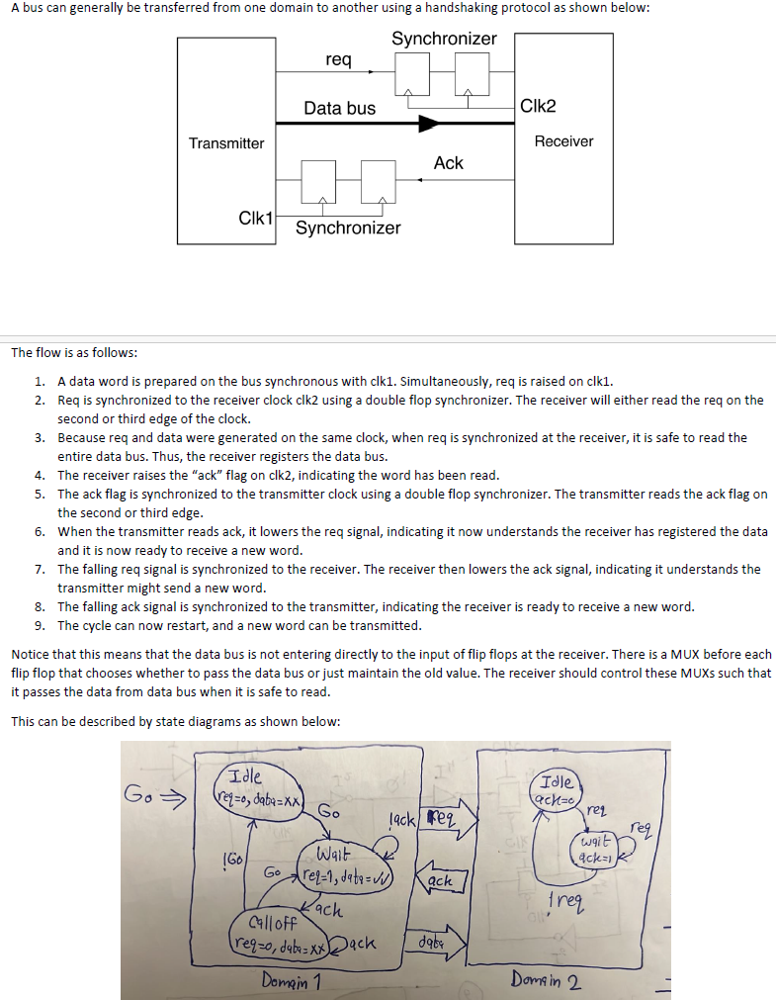
  - Asynchronous FIFO: to synchronize a burst of data (i.e. non-continuous transmission) from a fast domain to a slow domain.
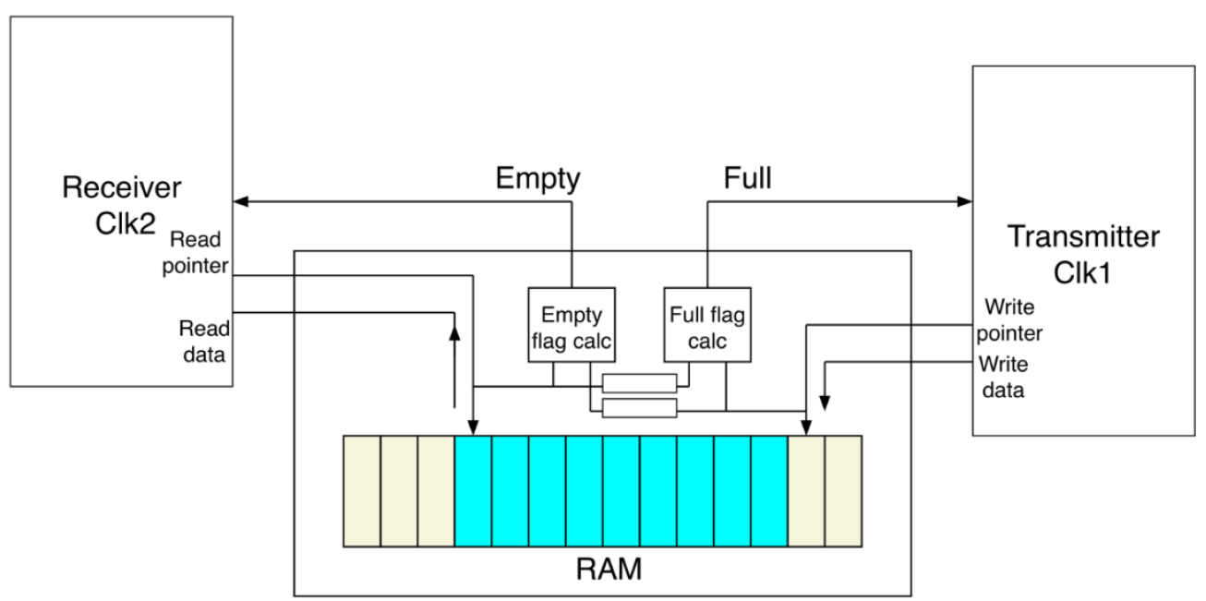
    - An asynchronous FIFO has a dual-port RAM, the Tx writes in it, and the Rx reads from it.
    - The Tx uses a write pointer that tells the next address that should be written in, and the Rx uses a read pointer that tells the next address that should be read from.
    - A full flag is designed to let the Tx know if the FIFO is full, and an empty flag is designed to let the Rx know if the FIFO is empty.
    - To know whether the FIFO is full or empty, the write and read pointers have to be compared. If they are equal, this indicates that the FIFO is either empty or full. Whether it is full or empty depends on the last update; if the write pointer was incremented and this caused the equality between it and the read pointer, then the FIFO is full, and if the read pointer was incremented and this caused the equality between it and the write pointer, then the FIFO is empty.
    - The write pointer is synchronized to the Tx domain, while the read pointer is synchronized to the Rx domain. Hence, to calculate the full flag, the read pointer has to be synchronized to the Tx domain, and to calculate the empty flag, the write pointer has to be synchronized to the Rx domain.
    - Since the write and read pointers are counters, they can be gray-encoded and hence use multiple double-flop synchronizers.
    - Bema en el write wel read pointers bey get synchronized abl ma ye get compared for the full and empty flags calculations, w bema en fih 1-cycle uncertainty fel double-flop synchronizers, hal da keda ma3nah en momken ye7sal failure be ma3na en kan el mafrood yeb2a el full flag marfo3 w bel taly el Tx mayektebsh bs bsbb el synchronization da el full flag matrafa3sh fel wa2t el sa7 w bel taly el Tx overwritten data makanetsh lesa et2aret, aw kan el mafrood yeb2a el empty flag marfo3 w bel taly el Rx maye2rash bs bsbb el synchronization da el empty flag matrafa3sh fel wa2t el sa7 w bel taly el Rx read data howa 2araha abl keda? La2 3ashan:
      - Full flag case: el write pointer beyeb2a abl el read pointer be location, w awel ma el Tx yekteb el write pointer bey increment. Delwa2ty el full flag hayshof el write wel read pointers 2ad b3d, bel raghm en momken ykon fi nafs el wa2t el read pointer got incremented, bs bsbb el synchronization lesa mawselesh el update da. Hal da failure? La2 la2en ana keda ka Tx mogarad bs mesh hakteb 3ashan ana faker en el FIFO full bel raghm en howa la2 mesh full howa bs el read pointer et2a5ar 3alaya eno yegely, fa da waste mesh failure.
      - Empty flag case: el read pointer beyeb2a abl el write pointer be location, w awel ma el Rx ye2ra el read pointer bey increment. Delwa2ty el empty flag hayshof el write wel read pointers 2ad b3d, bel raghm en momken ykon fi nafs el wa2t el write pointer got incremented, bs bsbb el synchronization lesa mawselesh el update da. Hal da failure? La2 la2en ana keda ka Rx mogarad bs mesh ha2ra 3ashan ana faker en el FIFO empty bel raghm en howa la2 mesh empty howa bs el write pointer et2a5ar 3alaya eno yegely, fa da waste mesh failure.
    - What should be the depth $D$ of an asynchronous FIFO?
      - Assuming the Tx is operating with a clock frequency $f_{A}$, the Rx is operating with a clock frequency $f_{B}$, no idle write or read cycles during the burst (i.e. Tx/Rx is writing/reading every clock cycle), the burst length is $L$:
$$D=ceil\left[\left(1-\frac{f_{B}}{f_{A}}\right)L\right]$$
      - Assuming the Tx is operating with a clock frequency $f_{A}$, the Rx is operating with a clock frequency $f_{B}$, the Tx has $i_{A}$ idle write cycles, and the Rx has $i_{B}$ idle read cycles, the burst length is $L$:
$$D=ceil\left[\left(1-\frac{f_{B}/(i_{B}+1)}{f_{A}\left(i_{A}+1\right)}\right)L\right]$$
- How to synchronize a reset signal?
  - The de-assertion of a reset signal might cause recovery or removal time violation.
  - Using a reset synchronizer guarantees asynchronous assertion and synchronous de-assertion.
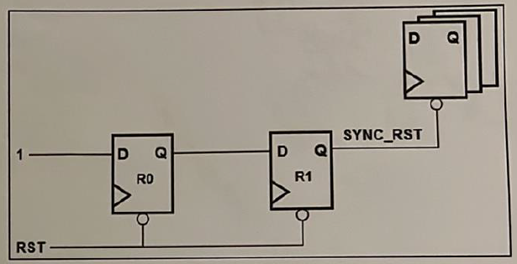

Temsah STA
- What is the difference between propagation and contamination delays?
  - Minimum propagation delay: the minimum time the output of a gate is guaranteed to be the correct value in the best‑case scenario when charging/discharging happens through the smallest resistance path → not important.
  - Maximum propagation delay: the maximum time the output of a gate is guaranteed to be the correct value in the worst-case scenario when charging/discharging happens through the largest resistance → used in setup analysis.
  - Contamination delay: the minimum time the output of a gate can begin changing, but this does not mean it has reached its final value → used in hold analysis.
- Tab howa leeh aslan fel contamination delay ben2ol “but this does not mean it has reached its final value”, howa el output bta3 gate mesh beyewsal lel final value 3la tool?
  - La2 el output bta3 gate momken yo3od ye glitch el awel w da bsbb en el inputs bta3t el gate de mesh guaranteed enaha kolaha tewsal fi nafs el wa2t, fa momken different transistor paths teshtaghal fi different times.
- What is meant by minimum pulse width?
  - The library provided by a fab contains a minimum pulse width for clock signals as well as asynchronous inputs to a flip flop. The synthesis tool uses these numbers in the following manner:
    - If input low pulse < minpwl minimum pulse width violation.
    - If input high pulse < minpwh minimum pulse width violation.

- How can we fix a setup violation?
  - A setup violation means the data arrived later than it should. So, we should either make it arrive earlier (i.e. take shorter delay) or give it more time:
    - Make it arrive earlier (i.e. take shorter delay):
      - Pipelining (frontend).
      - Retiming (frontend or synthesis, if path allows).
      - Lower combinational gates delay ($τ∝RC$) by lowering the resistance ($R∝\frac{1}{I}=\frac{1}{\frac{K}{2}{\left(V_{DD}-V_{th}\right)}^{2}}$) without touching the capacitance:
        - Increase $V_{DD}$ (backend, rarely possible because it requires a different library unless you have multi-voltage domains).
        - Decrease $V_{th}$ (backend, possible if the library has multiple threshold voltage flavors).
    - Give it more time:
      - Positive skew (backend).
      - Lower $f_{clk}$ (rarely acceptable).
- How can we fix a hold violation?
  - A hold violation means the data arrived earlier than it should. So, we should make it arrive later (i.e. take longer delay) or give it less time:
    - Make it arrive later (i.e. take longer delay):
      - Add buffers (backend).
      - Higher combinational gates delay ($τ∝RC$) by raising the resistance ($R∝\frac{1}{I}=\frac{1}{\frac{K}{2}{\left(V_{DD}-V_{th}\right)}^{2}}$) without touching the capacitance:
        - Decrease $V_{DD}$ (backend, rarely possible because it requires a different library unless you have multi-voltage domains).
      - Increase $V_{th}$ (backend, possible if the library has multiple threshold voltage flavors).
    - Give it less time:
      - Negative skew (backend).

Temsah Synthesis
- What are the inputs and outputs of a synthesis tool.
  - Inputs:
    - RTL.
    - Technology files.
    - Constraints file.
  - Outputs:
    - Technology-dependent gate-level netlist.
    - Reports.
- What are the steps of synthesis?
  - Translation: translates your RTL code into technology-independent gates using a generic library called G-tech (all gates are 2-input gates).
  - Mapping: maps the G-tech library into your specific technology library.
  - Optimization: optimizes given your set of constraints.
- Why does the fab deliver different views of the technology library? What are these views?
  - El fab bey deliver different views 3ashan kol EDA tool betefham view mo3ayan.
  - There are 3 views:
    - Behavioral view (.v): lama ben5allas synthesis, fa beyetla3lena gate-level netlist. Fa beneb2a 3ayzeen ne3mel gate-level simulation lel netlist de 3ashan nshoof el behavior ma3 wogod el delays. Bs el netlist de just fiha shwayet gates, mafehash el delay info wel functionality bta3t el gates de. Fa el beyeb2a fih el ma3lomat de howa el behavioral view bta3 el library. W bel taly benedy el simulator el gate-level netlist wel behavioral view.
    - Liberty view (.lib): da el view el betefhamo el synthesis tool wel te2dar testa5demo 3ashan te map el RTL bta3ak da le gate-level netlist, w kaman te2dar te provide you with timing, area, and power reports using the info in this view.
    - Abstract view (.lef).
    - Layout view (.gds).
- How does the fab characterize the delay of a gate?
  - Using Non-Linear Delay Model (NLDM): given en el gate de da5al 3leeha input transition kaza w 3leeha load capacitance kaza, fa el propagation delay bta3ha hayeb2a kaza (both rise and fall propagation delays).
- Bs hangeeb el input transition wel load capacitance bto3 el gate menen?
  - Mahowa given input transition mo3ayan w load capacitance mo3ayan, ana mesh bs b3rf el propagation delay bta3 el gate, la2 ana kaman b3rf el output transition time bta3ha (both rise and fall transitions). Wel output transition bta3 el gate el ableya howa el input transition bta3y.
  - El load capacitance el 3la gate mo3ayana bn3rfo men el output capacitance bta3ha, el input capacitance bta3 el gate el b3deha, wel wiring capacitance el mabenhom.
- Are the power reports from the synthesis tool optimistic or pessimistic?
  - Pessimistic la2en ezay el synthesis tool bt7sb el power bta3 gate mo3ayana? Bta5od el raqam men el technology files. Tab wel raqam da obtained ezay? El fab 7atet en 3and input transition kaza w output capacitance kaza el power bta3 el gate de kaza. Bs tab3an zy ma7na 3arfeen el switching/dynamic power beya3tamed 3la el activity factor $α$ el howa bya3tamed 3al design bta3ak. Fa tab3an el fab my3rfsh enta hate3mel eh fel design bta3ak, fa it assumes the worst case w heya en $α=0.5$, fa da bey5ally el power reports pessimistic. Tab3an n5ally balna bardo en b3d el PnR lesa beyet7at el buffers bta3t el clock tree, bs 7ata b3d da still el power reports pessimistic.
- Timing is the most important design constraint. The tool first tries to meet the timing you specified, then it optimizes for area and power.
- What is the difference between STA and DTA?
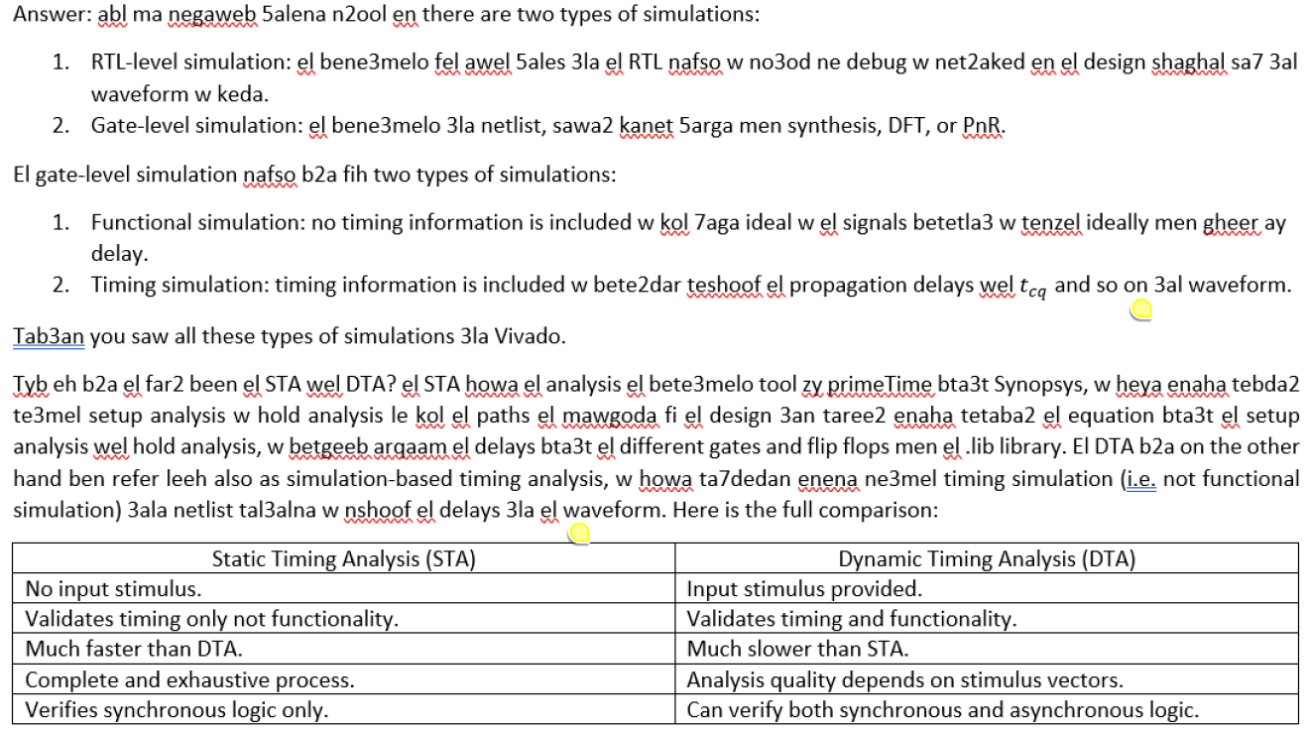
- How does we direct the tool to use slow-slow library in setup analysis and fast-fast library in hold analysis?
  - By setting the operating conditions constraint.
- When should we use a create_generated_clock constraint?
  - With clock dividers and clock gating cells.
- What is the set_clock_uncertainty constraint?
  - Bey3araf el expected jitter and skew in the clock.
- What are the constraints that the tool needs to be able to do timing analysis for a flop-to-flop path?
  - create_clock
- What additional constraints do the tool need to be able to do timing analysis for input-to-flop and flop-to-output paths?
  - Input delay
  - Input transition
    - Write a certain value.
    - Define a resistor with a certain resistance.
    - Assume an input gate from the library (preferred).
  - Output capacitance
  - output delay
- What about an input-to-output path?
  - We define a virtual clock for such paths.
- What is the use of set_dont_touch_network constraint?
  - Da mainly benesta5demo ma3 el clock wel reset signals. El tool lama betla2y wire bey drive loads kteer (zy el clock wel reset), bet7ot 3leeh buffers 3ashan tesa3do. Tab3an e7na 3arfeen en keda keda el clock wel reset dool lesa hanozbot-hom fel PnR, fa mesh 3ayzeen el synthesis tool t7ot ay buffers men nafsaha. 7ata lw zahar m3ak “max_transition” aw “max_capacitance” violations b3d el synthesis tanesh-ha.
- This is how the synthesis tool reports a setup path:
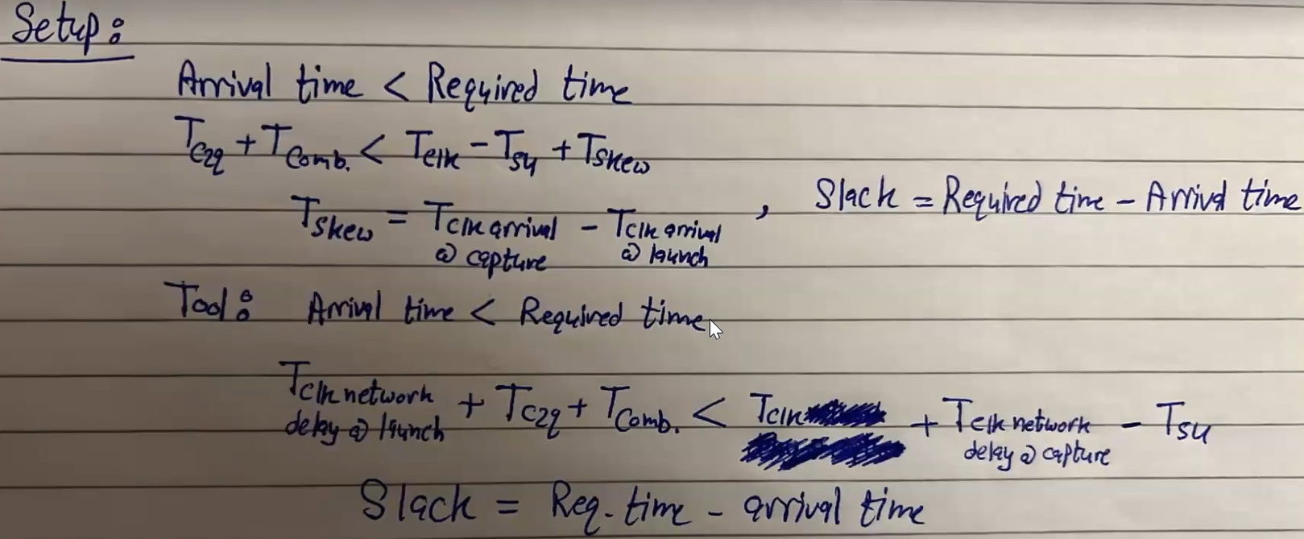
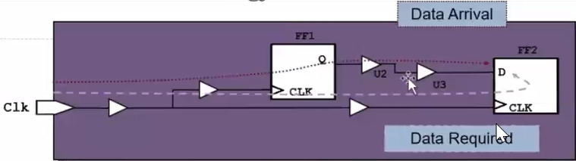
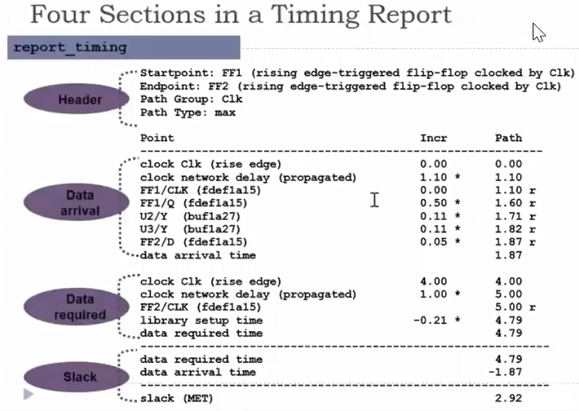
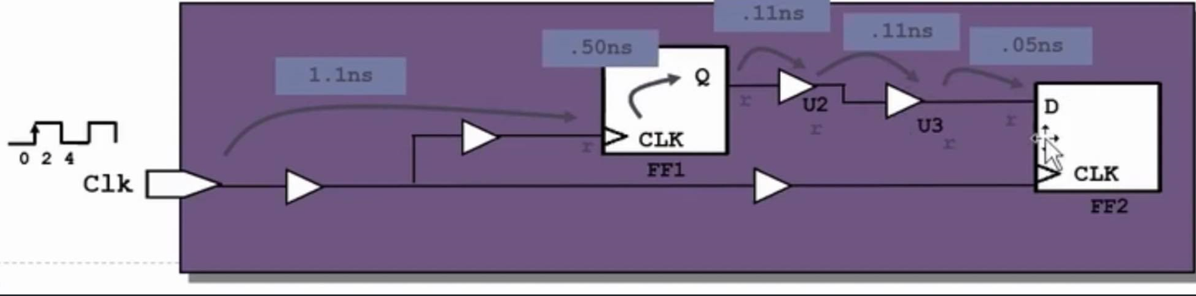
- What are the uses of set_max_transition and set_max_capacitance?
  - Lw node leha fanout kebeer (i.e. bet drive gates kteer), fa hateb2a shwaya capacitance kebera, w bel taly el transition time 3leeha hayeb2a keber awy. Tab eh el 7al? Enena n7ot buffer kebeer 3al node de ye drive el capacitance el kebera de.
  - Usually, we neglect any max transition or max capacitance violations fel synthesis 3ashan de 7aga hat get handled better fel PnR b3d ma n3ml placement w routing le kol haga.

Temsah Power
- Types of power:
  - Static power:
    - Leakage power:
      - Subthreshold leakage: when $V_{gs}<V_{th}$, the transistor is not just “off”, it is in the subthreshold region where current flows and hence leakage occurs.
      - Gate oxide tunnelling: the oxide layer thickness between the gate and channel scales down, hence at some point it allows gate current and hence leakage occurs.
  - Dynamic power:
    - Switching power
    - Short-circuit power: to cancel it, $V_{DD}=2V_{th}$.
    - Glitch power: it is nothing but a mix of switching power and short-circuit power. Due to glitches, the activity factor ($α$) of a signal can exceed 1.
- Switching power reduction techniques:
  - Activity factor ($α$):
    - Clock gating.
    - Avoid using XOR gates as much as possible (e.g. comparators).
    - Operand isolation.
    - Use shifters instead of constant multiplications.
  - Load capacitance ($C_{L}$):
    - Gate capacitance: use smaller gates (but need to have a slack).
    - Wire capacitance: do better floor planning, placement, and routing to decrease the wires’ length.
  - Frequency ($f$): multiple frequencies.
  - Supply voltage ($V_{DD}$): multi-voltage domains.
- Short-circuit power reduction techniques:
  - Multi-threshold domains.
- Glitch power reduction techniques:
  - Operand isolation.
- Leakage power reduction techniques:
  - Multi-threshold domains.
  - Power gating.
- Using latch-free clock gating could cause:
  - “Pulse clipping” and minimum pulse width violation: lw el gated clock kanet be 1 wel enable be 1 w fag2a el enable nezlet le 0.
  - Setup/hold time violation and minimum pulse width violation: lw el gated clock kanet be 0 wel enable be 0 w fag2a el enable tel3et le 1 w kanet el input clock be 1, fa el gated clock tetla3 heya kaman be 1 (called “Spurious clocking”).
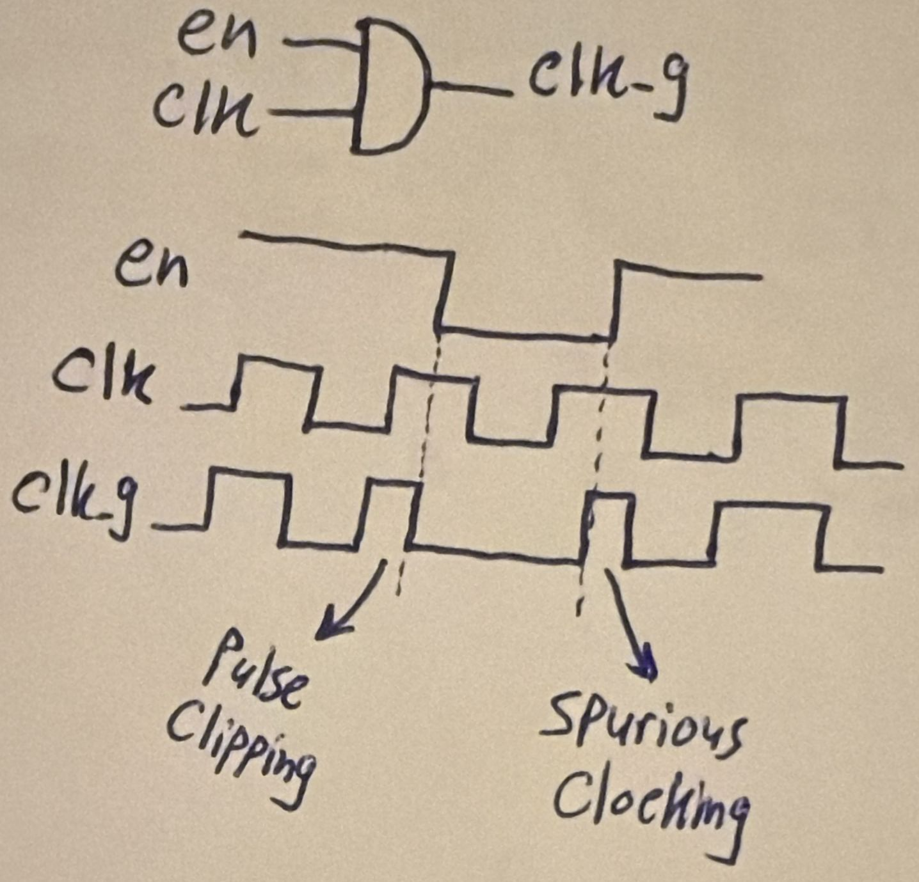
- Latch-based clock gating:
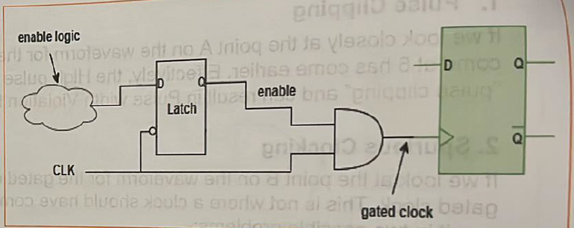
- Even after using a latch-based clock gating, pulse clipping and spurious clocking can still happen due to differential delay between the latch and the AND gate. To solve this, both the latch and the AND gate are integrated together in a single cell called “Integrated Clock Gating” (ICG) cell where the two gates are placed and routed such that to eliminate any differential delay. Then, the gate is used just as it is; the placer and the router do not edit it not to cause any differential delay.
- We said that increasing the threshold voltage to $V_{th}=\frac{1}{2}V_{DD}$ eliminates the forbidden region and hence eliminates the short-circuit power. We then said that playing with $V_{th}$ (i.e. multi-threshold domains) can help in leakage, but how? Again, increasing the $V_{th}$ lowers the leakage power. Thus, e7na dayman nefsena nesta5dem high $V_{th}$ 3ashan ne2alel el leakage (i.e. static) power wel short-circuit (i.e. dynamic) power, bs watch out for the delay.
- How is power gating done?
  - Using a retention flop, where the first latch takes in the normal supply voltage $V_{DD}$ that can be gated, while the second latch takes in another smaller supply voltage $V_{DD,on}$ that is always on even when $V_{DD}$ is off so that it retains its output value even when power is off.
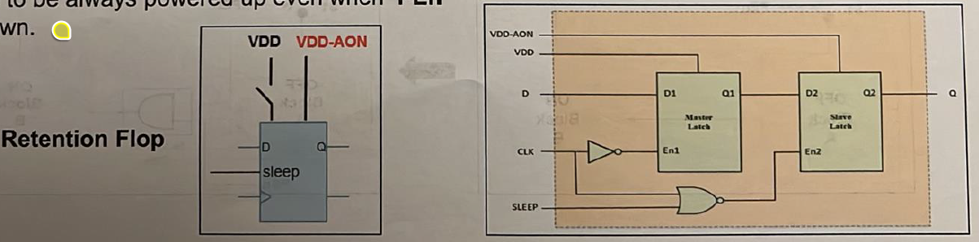

Temsah Formal Verification
- Formal verification has three types:
  - Equivalence checking
  - Modeling checking
  - Theorem proving
- How is equivalence checking done?
  - You give the formal engine the RTL and a gate-level netlist, and through mathematical transformations and Boolean equations, the tool compares the functional equivalence checking between both. This is done through dividing the design into logic cones and compare points.
- What is model checking?
  - Da el inputs bta3to mesh RTL w netlist b2a, la2 da el input bta3o RTL w a set of properties/specifications enta 3ayezha tefdal met7a2a2a 3la tool (e.g. SystemVerilog Assertions), w el haye3melo el model-checking engine eno exhaustively hay go through all possible states in your design b7ees ye make sure en el properties de dayman met7a2a2a, w lw la2a case mesh met7a2a2a fiha, hayedelak el set of inputs (i.e. stimulus) el bey5aly property mesh met7a2a2a, which we call a counterexample.

Temsah DFT
- Possible issues during fabrication/manufacturing:
  - Short circuit
  - Open circuit
  - Stuck-at-1
  - Stuck-at-0
- The nearer the gate is towards the input, the easier it is to control its inputs, but the harder it is to observe its output.
- The DFT logic improves controllability and observability through replacing all flip flops in the design with scan flops. A scan flop is nothing but a normal flip flop with an input multiplexer with a “scan enable” selection line that selects between either the functional path (i.e. the normal design path) and the scan path. This way, we can build a long shift register starting from a scan input port to the chip, which can be used by the ATE tool to pass in the test pattern generated by the ATPG for testing the chip for manufacturing defects. An example is shown below:
- Every scan chain has its own Scan Enable (SE) & Scan Input (SI) input ports and Scan Output (SO) output port.
- DFT testing consists of 3 steps (check the example below):
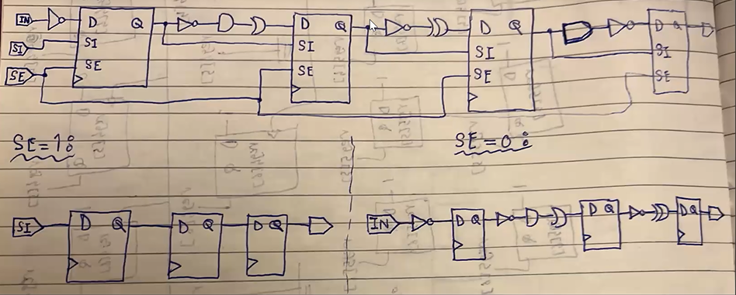
  - Shift in: set SE = 1, SI port to the value you want to drive the target node with, and then wait until SI’s value reaches the target node.
  - Capture: once the SI’s value reached the target node, now set SE = 0 to activate the functional path.
  - Shift out: the next clock cycle, set SE = 1 again to shift the captured value to the output of the scan chain.
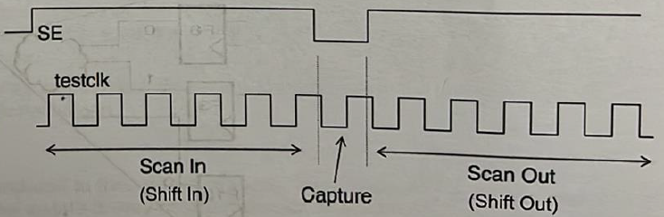
- The DFT tool may unnecessarily be able to replace all flip flops in your design by scan flops. Accordingly, the tool reports a “coverage” number indicating the percentage of nodes it could reach.
- What is the timing overhead of adding the DFT logic?
  - The additional multiplexer at the input of each flip flop causes a higher setup requirement on the functional paths.
  - Scan flops have higher clock-to-q delay as the flop now drives an additional load, which is the scan-in port of the next flop.
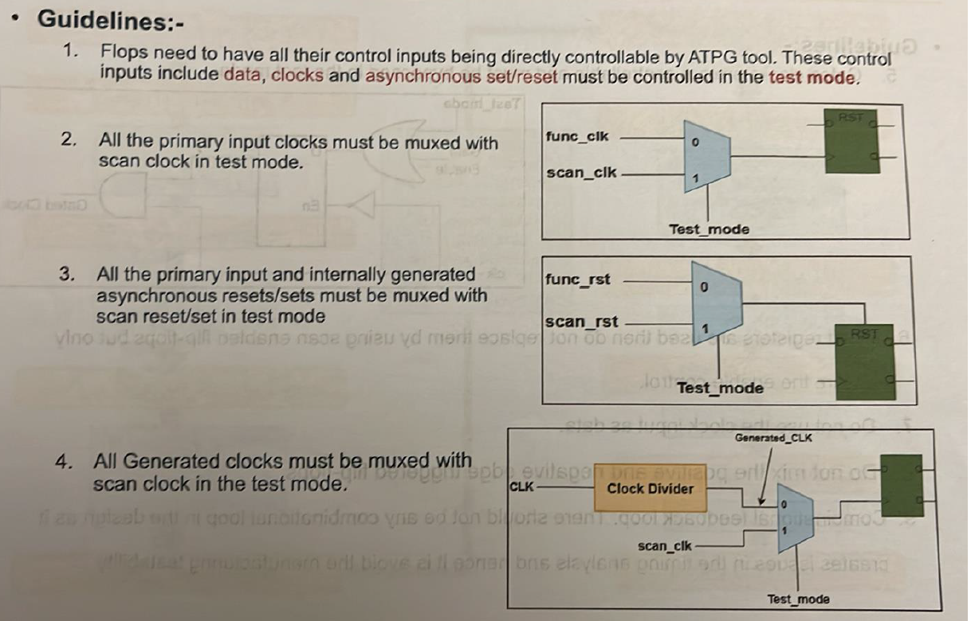
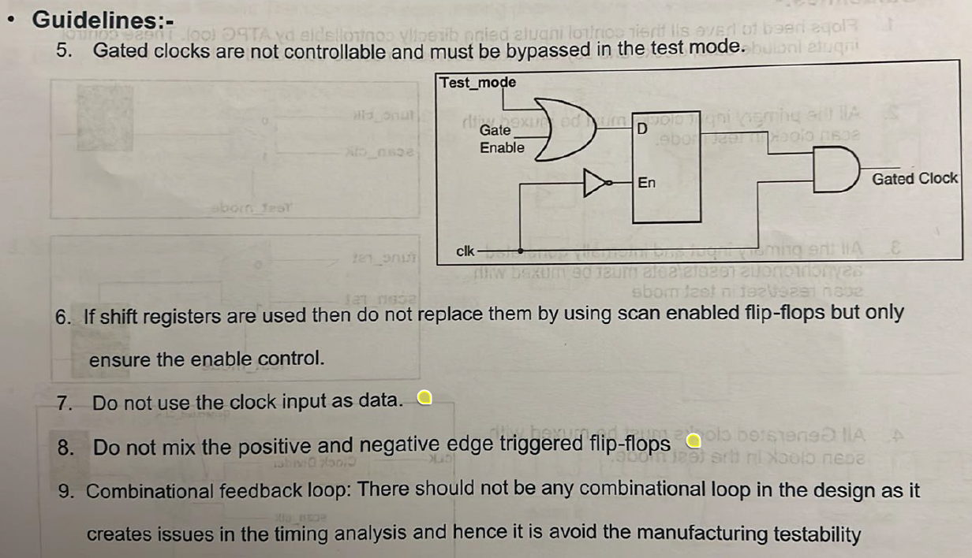

DSP Design Guide
Nothing worth writing really.

FPGA
- 7aga mofeeda gedan ne3melha w heya enena ne isolate shwayet operations keda as separate module files 3ashan lama negy le 5atwet el FPGA momken simply nsheel el RTL bta3 el operations de el e7na katbeno w ne replace it be IPs men Vivado zy:
  - General multiplier.
  - Constant multiplier.
  - Memories.
This gives us better/easier control over the block in terms of resource utilization and pipelining.
- Benzabbat el “strategies” bta3t el synthesis wel implementation to give better results.
- FPGA fabric:
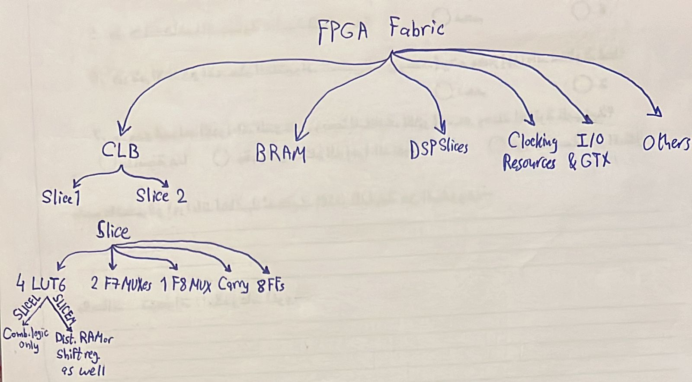
- The propagation delay through a LUT is independent of the function implemented.
- A power report on Vivado looks like this:
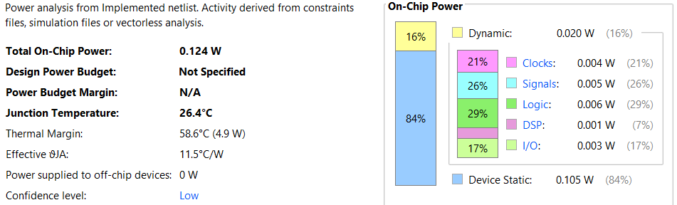
The power is divided into:
  - Static power: depends on the technology used, which is already determined once we selected a certain FPGA.
  - Dynamic power: switching power, simply.
- The confidence level of the previous power report is low, why? Because no simulation file was provided for the tool to estimate the activity factor of the different signals. We have to do post-implementation functional simulation and generate a SAIF file to provide it for the tool.
- The DSP slice looks like this:
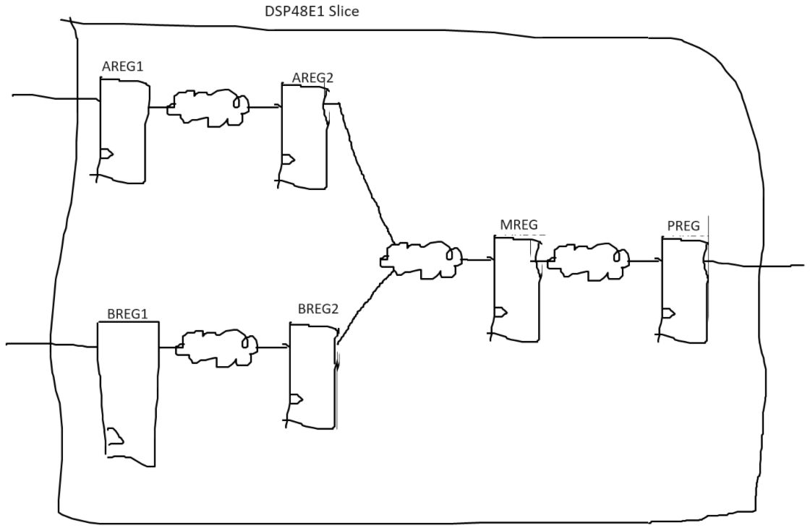
  - The multiplier is between AREG2/BREG2 and MREG.
  - All pipelining registers should be used for maximum performance possible:
    - AREG1/BREG1 to isolate the input delay.
    - PREG to isolate the output delay.
    - AREG2/BREG2 and MREG should be used to isolate the multiplier.
  - To force the synthesis tool to infer a DSP slice for your multiplier, you can either:
    - use the IP catalog, or
    - (recommended) write your RTL in a way that forces the synthesis tool to infer a DSP slice. How? 7ot two registers abl w two registers b3d el multiplier. W lazem el registers de el reset bta3hom yeb2a synchronous active-high 3ashan el registers el fel DSP slices keda.
- The retiming option is very important to enable while synthesis, it helps a lot!
- For small memories (ROM/RAM), use distributed RAMs. For large memories (ROM/RAM), use block RAM.
- Vivado can draw a schematic for your RTL using “Elaborated Design”.
- Pin assignment heya el step el hatwassal fiha your design ports to the FPGA ports.
- The ILA stores the samples captured from the probes in BRAMs, so make sure you leave enough BRAMs for the ILA.

DPD
- The story to tell:
  - Lama bada2na neshtaghal 3leeh makansh lesa leeh customer, da kan aslan mashroo3 ta5arogy. El 7asal en Analog Devices el most profitable product bta3ha howa el power amplifiers. W tab3an el non-linearities bta3t el PAs heya inevitable, fa lazem kan el customers bto3 el PAs bto3na beye3melo their own DPD 3ashan ye linearize our PAs. Fa gat el fekra en tab w leeh mane3melsh e7na el DPD bema enena aktar nas 3arfa el PA la2eno bta3na, fa nzl el DPD ka mashroo3 ta5arog w ana el eshtaghalt 3leeh. 3amalt shoghl kwayes fa they hired me, w kmlt b2a shoghl 3leeh w lesa mfeesh specific customer. W kan el tafkeer howa eno hayeb2a ASIC, fa olna 5aleny anazelo el awel 3la FPGA w lama teb2a el denya tamam nebda2 netalla3o fi test cell ka ASIC. W f3ln bada2t ashtaghal 3al asas da w I deployed it 3la FPGA Zedboard, bs tab3an de FPGA da3efa, fa kanet el clock frequencies el ba2dar awsalaha mesh bet3ady el 350 MHz, we7na kona 3ayzeen aktar men keda bekteer. Fa 3amalt comparative study sa3et-ha maben el Zedboard w board tanya mawgooda heya el Zynq Ultrascale+ ZCU104 w I showed en ne2dar newsal le almost 900 MHz 3la el Ultrascale+. Fa gat el FPGA w nazelt 3leeha el DPD w I tested el kalam da fel lab w kan kol haga tamam. L7d hena makansh fih customer lel DPD specifically.
  - B3d keda geh customer kona already bene3melo chip fiha power amplifier, fa kan interested el DPD efforts el 3amaltaha, bs makansh fih area kafya 3al chip enena nenazelo ka ASIC, fa fakkarna f 7al w howa en el chip kan already 3leeha processor ARM Cortex-M0, fa why not nenazelo just ka software w neb2a keda ma5adnash area wala haga. Bs again el challenge kan en M0 da da3eef wel DPD me7tag frequency 3alya, fa I made another comparative study been M0 w M85 w I proved en ne2dar ne meet el specs using M85. W da 7aleyan el e7na shaghaleen 3leeh, how to deploy the DPD on ARM Cortex M85. Fa hena ana ba7awel akteb C code lel DPD.
  - Delwa2ty b2a el kalam ma3 customer tany eno 7abeb el DPD yeb2a ASIC, w bel taly bada2na nefakkar enena nenazel el DPD RTL el ana 3amalto abl keda 3al FPGA kolo ka test cell, y3ny ASIC, w ta7dedan 3la technology 22FDX bta3t GlobalFoundaries, de actually el e7na mtalla3en 3leeha a5er two chips eshtaghalna 3leehom. Bs m2agelen da shwaya bs 3ashan el seka el tanya bta3t el C el tapeout bta3ha 2arrab w leha higher priority. Fa el mafrood el goal b3d ma a5allaso ka C code eny abda2 fih ASIC, wel ana already 2ata3t fih shoot kbeer sa3et el FPGA.

Others
- I add muxes at all input ports for each block to isolate inputs to avoid unnecessary switching power consumption when block is not operating.
- What is the difference between “Generic” and “FPGA” folders?
  - The FPGA currently being used (Zedboard) has some properties that require us to write a special RTL for them. Here are these properties:
    - For the pipelining registers inside the DSP slices to be properly used by the synthesizer, you should use registers with a synchronous reset in your RTL. Thus, all RTL files written inside the "FPGA" folder use a synchronous reset.
    - According to AMD’s user guide, a good design practice from the utilization point of view is to use active-high control signals. Since the reset signal is considered a control signal, it is advised to let it be active-high as well.
    - For a block RAM to be inferred by the synthesizer, you should use synchronous-read memories. Thus, all RTL files written inside the "FPGA" folder use synchronous-read memories.
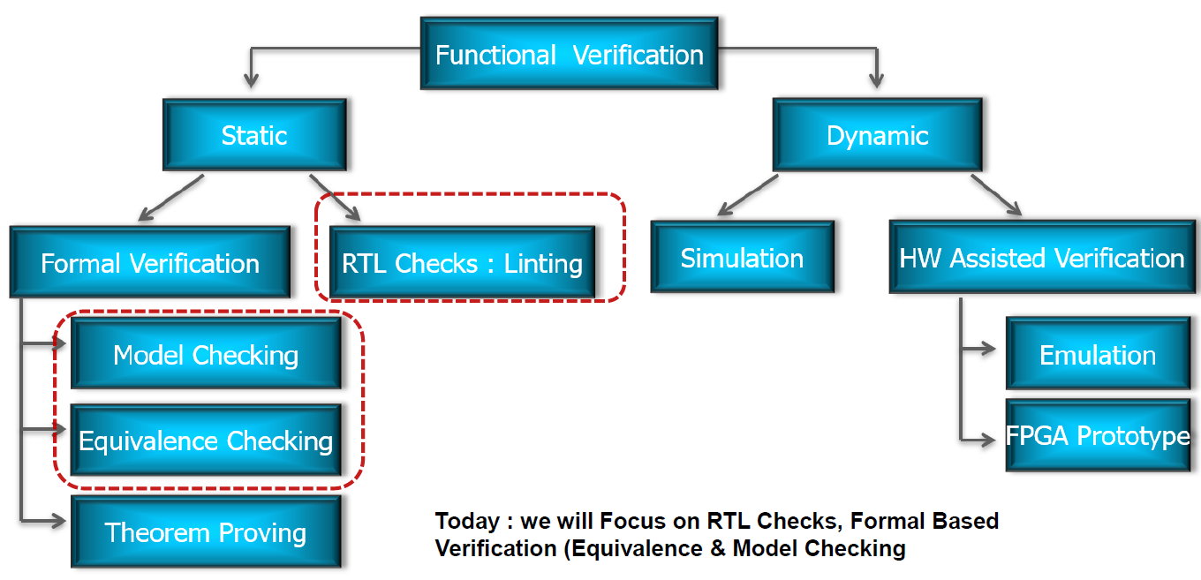

Interview Questions
- Why don’t we use latches?
  - Data has only $\frac{T_{clk}}{2}$ to propagate from one latch to another, while flip flops allow data to propagate in $T_{clk}-t_{su}$.
  - Being level triggered, latches are vulnerable to glitches.
  - Place and route tools find it harder to achieve timing closure in latch-based designs. Watch this from 5:20 to the end.

